Demo Video as per Guidelines
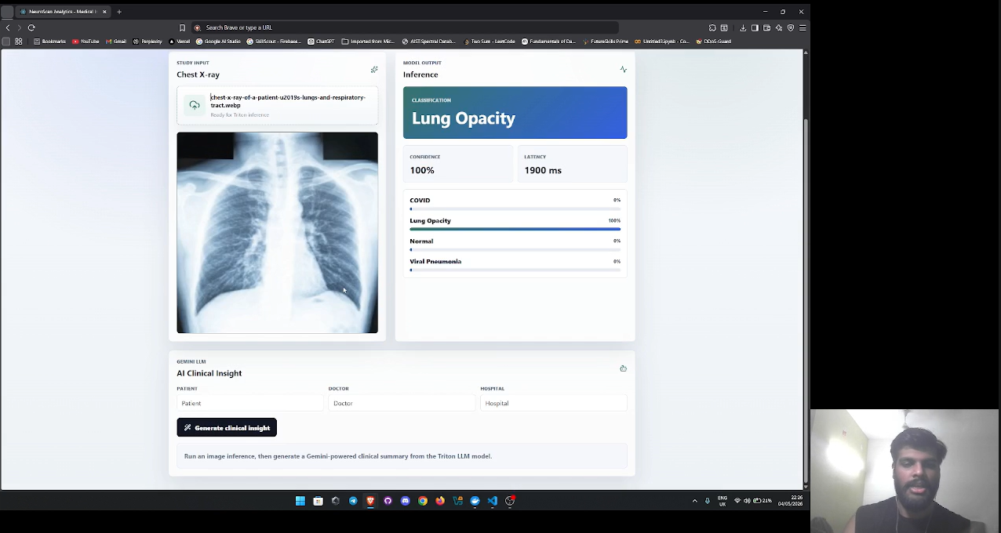

Fig 66 : Vidio Drive Link : https://drive.google.com/file/d/18JYR3sXfDPDSXboEszmCYPUOuGXtRJGT/view?usp=sharing
Github Repo and Fork
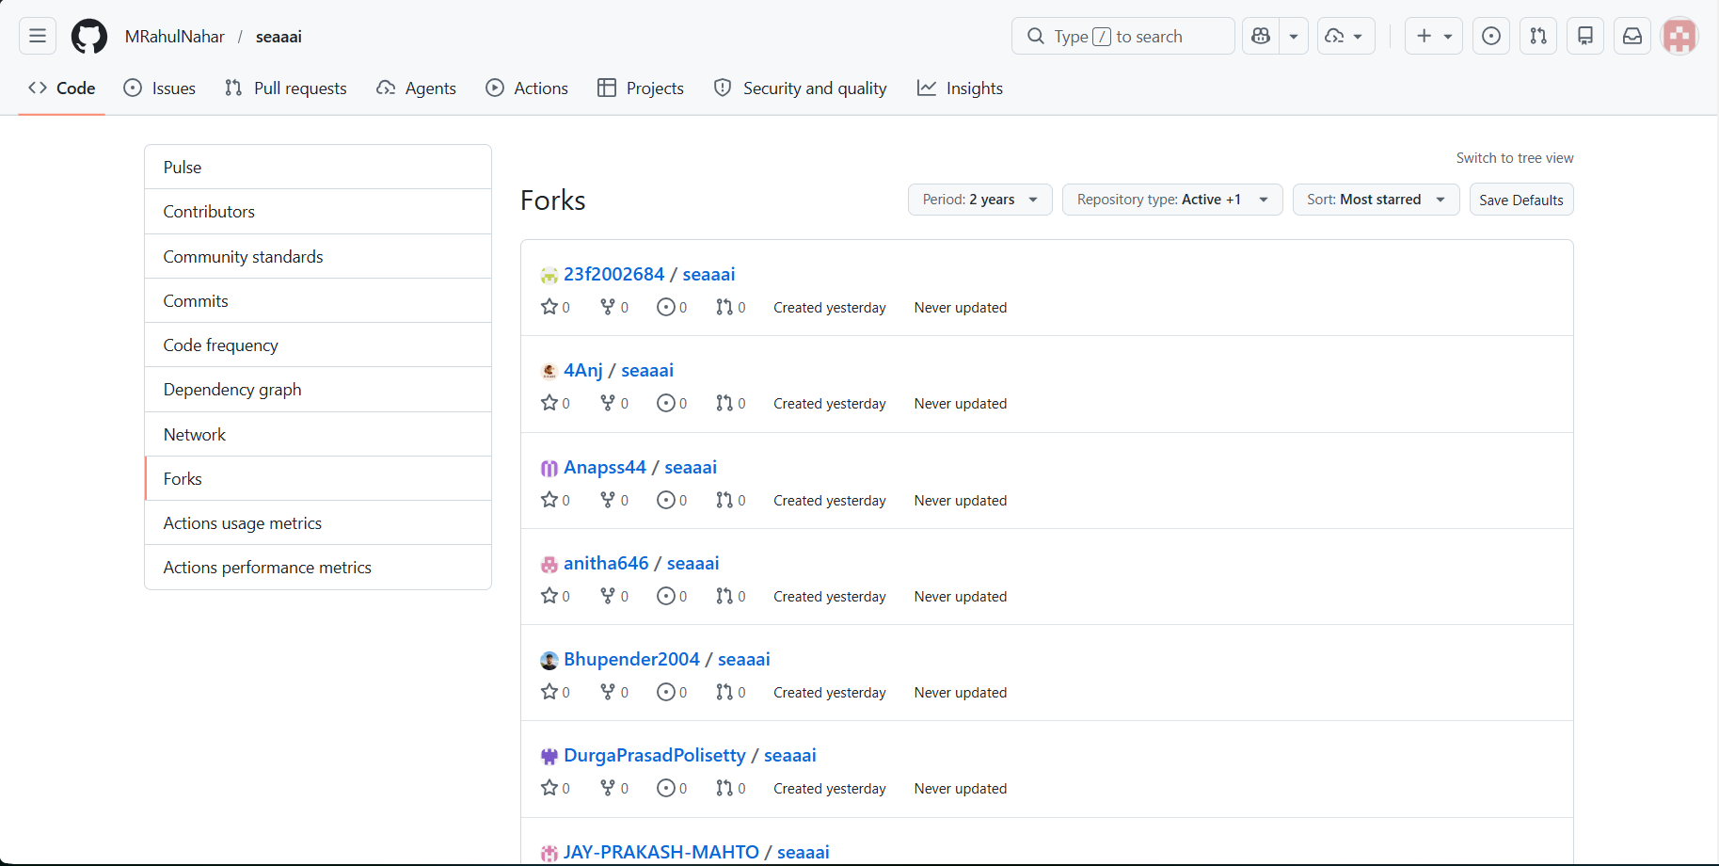

Fig 67: GitHub Repository Overview (PneumoAI Project) — https://github.com/MRahulNahar/seaaai

